Measuring The Pulse Of Prosperity: An Index Of Economic Freedom Analysis

1. Introduction :
- Project Title: Measuring The Pulse Of Prosperity: An Index Of Economic Freedom Analysis
- Team Members:
- Kona Sri Pavani - Tableau Developer.
- Puppala Sivamani - Data Loading and Preprocessing Lead.
- Gokanakonda Lokesh - Data Analyst.
- Sesetti Mohana Krishna - Visualization Specialist.
- Tibirisetti Satish - Documentation and verifies report quality.

2. Project Overview :
Purpose:
The Economic Freedom Index Analysis project aims to analyze and visualize the economic freedom of countries across the world using multiple indicators such as property rights, government integrity, tax burden, business freedom, trade freedom, and financial freedom. The project uses data analytics and Tableau dashboards to identify patterns, regional trends, and country-wise performance to support policy analysis and economic research.
Features:
- indicators across countries
- Country-wise and region-wise comparison
- Interactive Tableau dashboards
- Visual representation using bar charts, maps, and trend graphs
- Data-driven insights for decision-making

3. Architecture :
- Tableau Desktop / Tableau Public
- Interactive dashboards and stories
- Filters for country, region, and year
- User-friendly visual analytics interface
- Dataset preparation using Excel / CSV
- Data cleaning and preprocessing
- Calculated fields and measures in Tableau
Database / Data Source:
- Economic Freedom Index Dataset (CSV format)
- Publicly available global economic datasetsDatabase:

4. Setup Instructions :
Prerequisites:
- Tableau Desktop or Tableau Public
- Basic knowledge of data analytics
- CSV / Excel dataset
- Windows system
Installation :
Install Tableau Desktop
Open Tableau → Connect to Data
Load the Economic Freedom Index dataset (CSV)
Verify data types and measures
Create worksheets (country-wise, region-wise, indicators)
Build dashboards and story

Folder Structure :
Economic_Freedom_Analysis/
│
├── Dataset/
│ └── economic_freedom_index.csv
│
├── Tableau_Workbook/
│ └── economic_freedom_analysis.twbx
│
├── Dashboards/
│ └── country_region_dashboard.png
│
├── Documentation/
│ └── final_report.pdf

6. Dashboard & Story Design :
Dashboards:
- Country-wise Economic Freedom Score
- Region-wise Comparison
- Indicator-wise Breakdown
- Top & Bottom Performing Countries

Story:
- Global economic freedom overview
- Regional insights
- Key observations and conclusions

Data Flow Description :
- Economic freedom dataset is collected
- Data is cleaned and structured
- Dataset is loaded into Tableau
- Measures and dimensions are defined
- Visualizations are created
- Dashboards and stories are generated

Results :
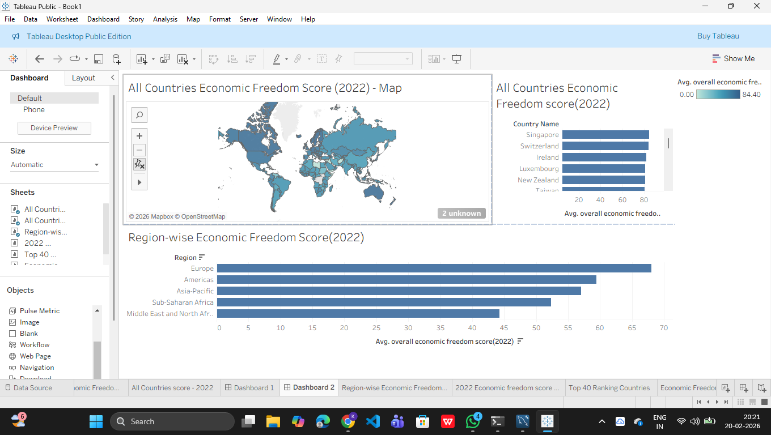

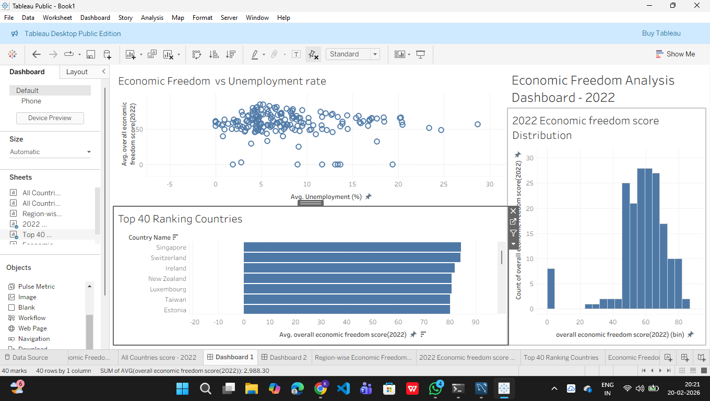
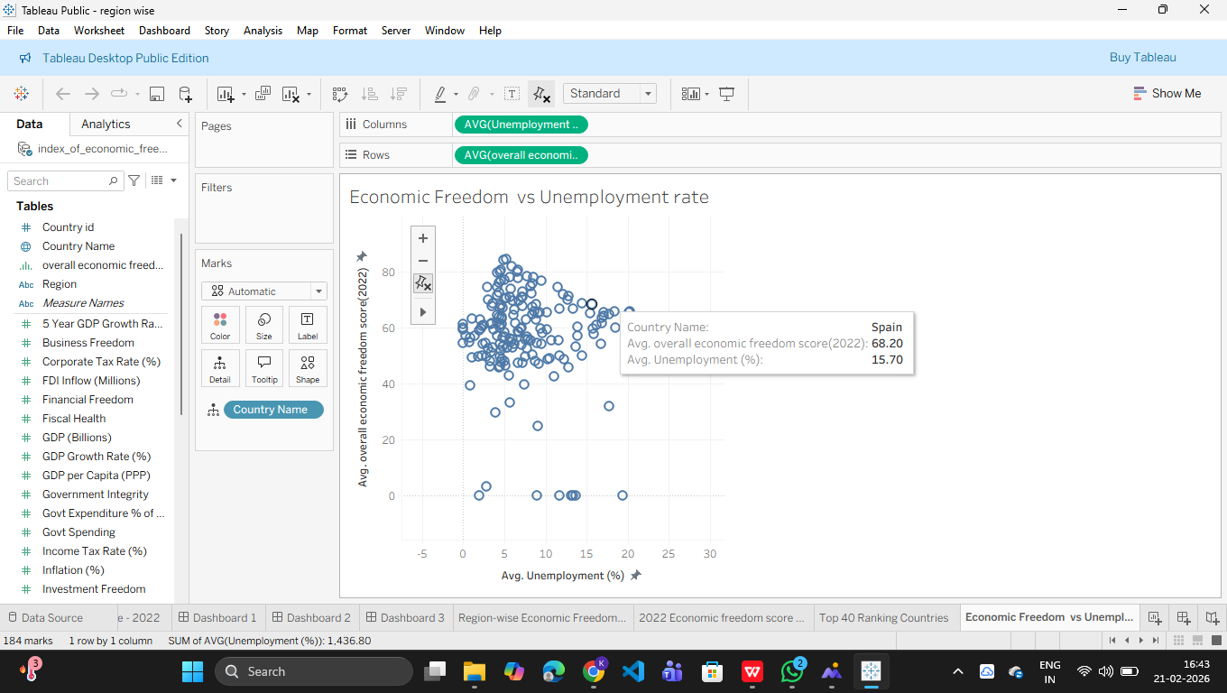
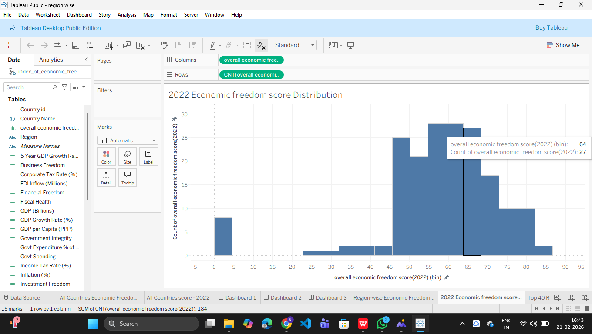
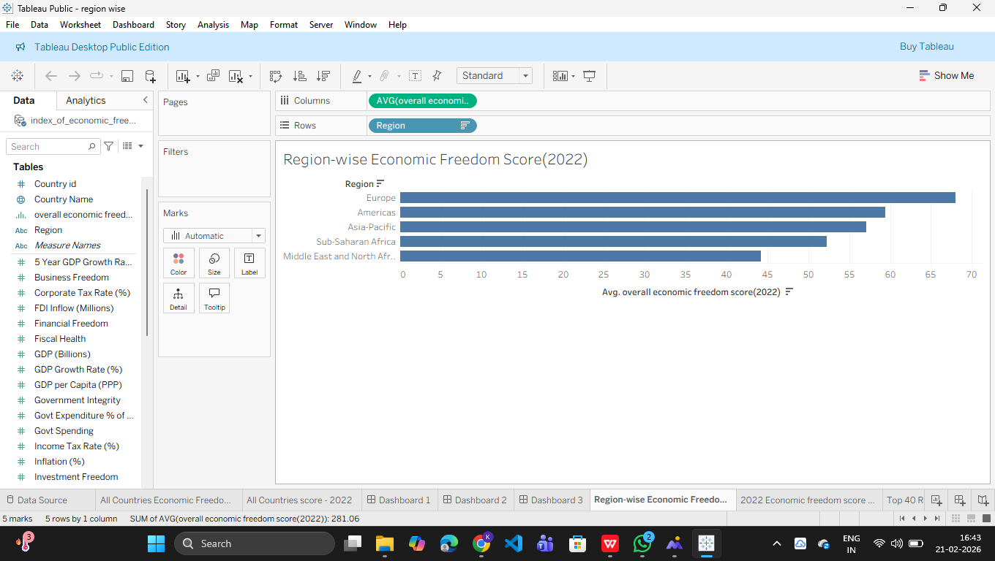

Advantages and Disadvantages :
Advantages:
- Easy data interpretation
- Interactive visual analytics
- Supports decision-making
- Scalable for future datasets

Disadvantages:
- Depends on data accuracy
- Limited to available indicators
- Static historical data

- Conclusion:
The Economic Freedom Index Analysis project successfully demonstrates how data analytics and Tableau visualization can be used to analyze global economic conditions. The project provides meaningful insights into economic freedom patterns and supports comparative economic studies.

11. Future Enhancements
- Add multiple years for trend analysis
- Integrate real-time data sources
- Advanced predictive analytics
- Policy recommendation module

